

TTM430 THERMAL TRANSFER PRINTER

Quick Start Guide

Operations Overview

Unpacking and Inspection

This printer has been specially packaged to withstand damage during shipping. Please carefully inspect the packaging and printer upon receiving the bar code printer. Please retain the packaging materials in case you need to reship the printer.

Unpacking the printer, the following items are included in the carton.

- One printer unit
- One Windows USB Key Drive for Drivers / Manuals.
- One quick installation guide
- One power cord
- One USB interface cable

If any parts are missing, please contact HellermannTyton Support: 1.800.537.1512


Printer Overview

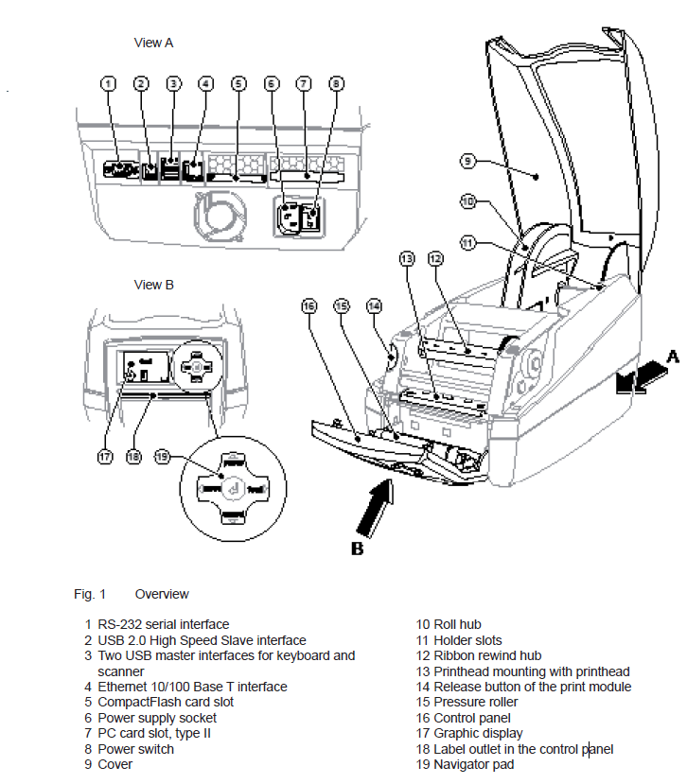
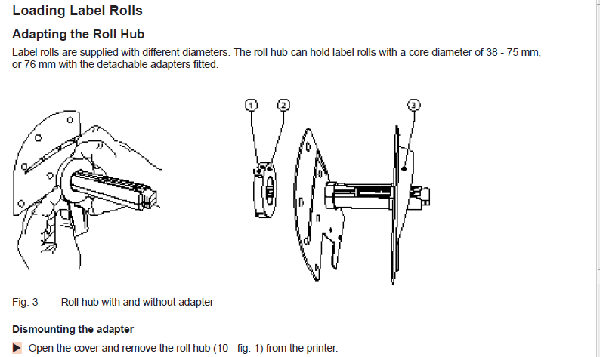
.. Continue to next page.
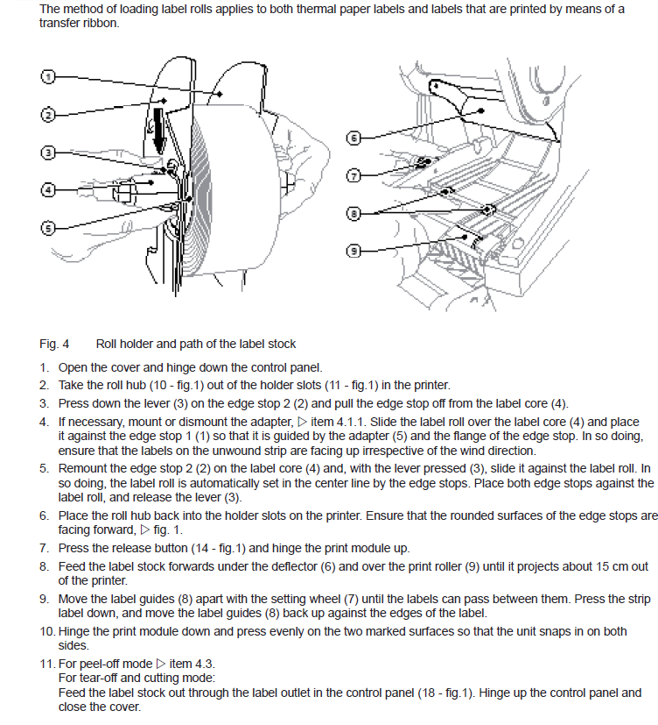

Loading Ribbon
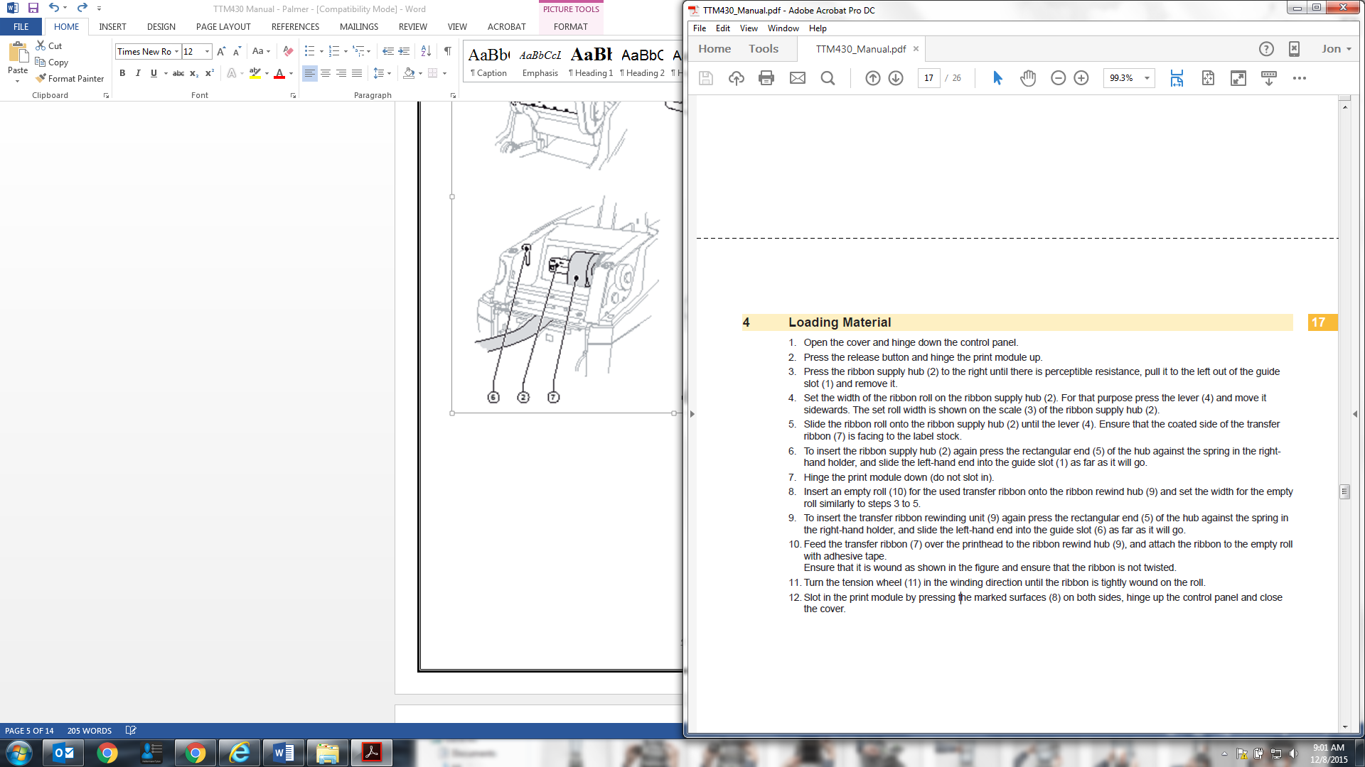
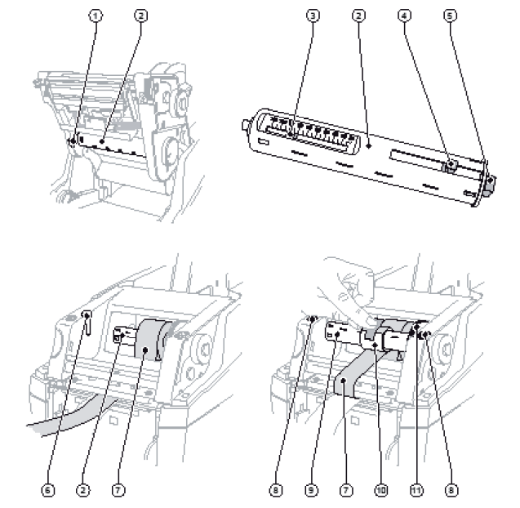
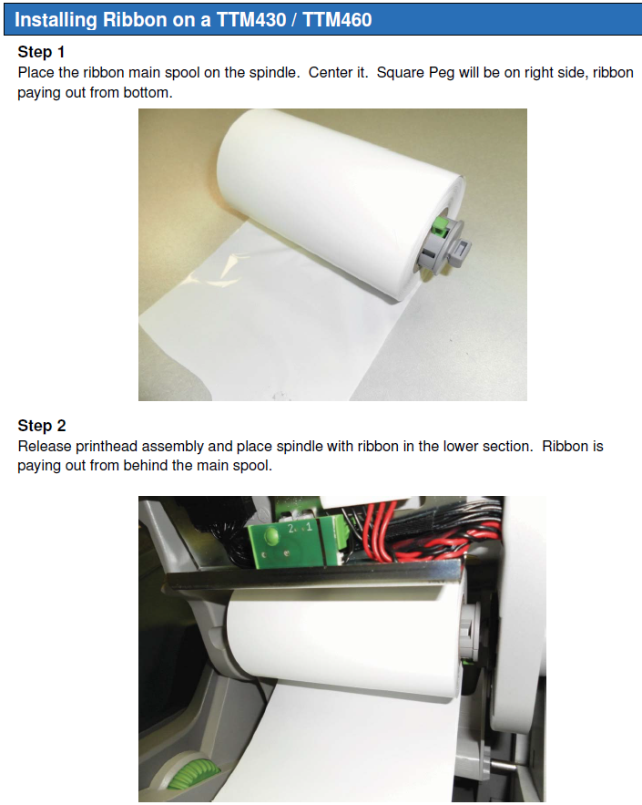
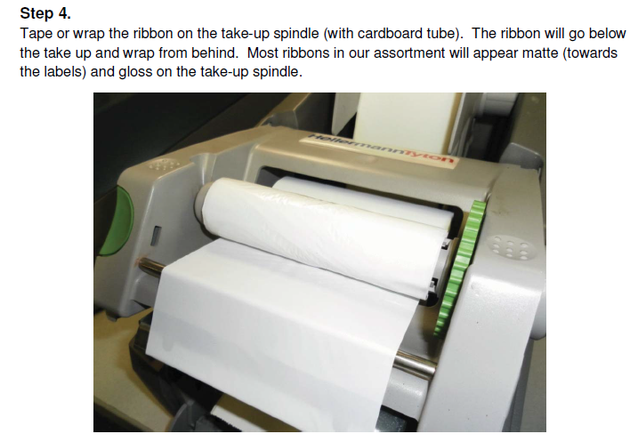
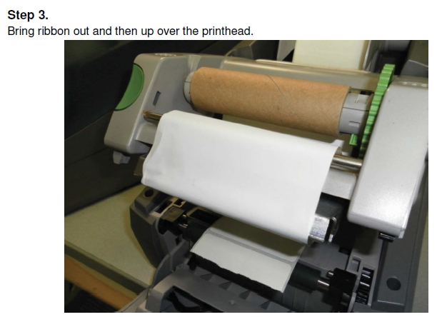

Lock down, push up face plate, and close lid.

Setup

Setting Up the Printer
Connecting to the Power Supply
The printer is equipped with a wide area network unit. The device can be operated with a supply voltage of
230 V~/50 Hz or 115 V~/60 Hz without adjustment.
Check that the device is switched off.
Plug the power cable into the power connection socket (6).
Plug the power cable into a grounded socket.
Turn on printer; driver should automatically load, but if NOT please continue to NEXT page.

Installing the printer drivers

Plug your USB stick into a separate port on your computer; this stick contains your printer driver.

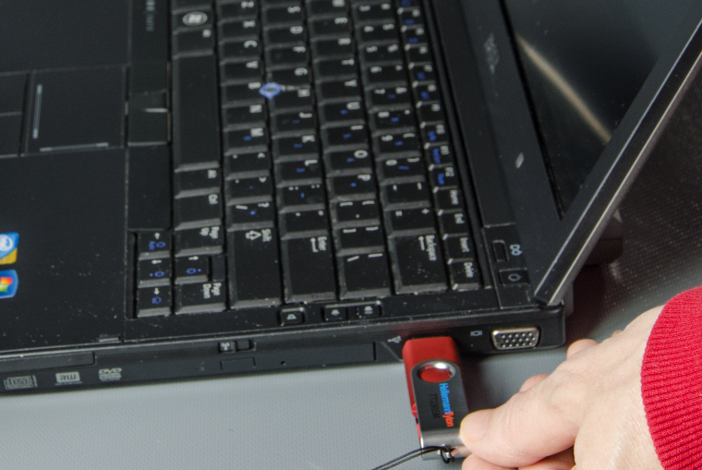

SELECT “Open folder to view files”

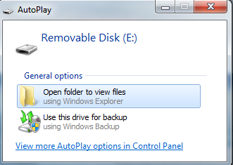

Access the files on the USB stick

DOUBLE CLICK ON PrnInst TO OPEN THE DRIVER INSTALLER

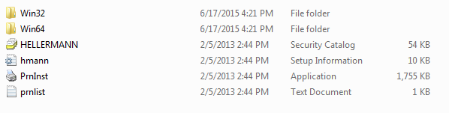

CLICK ON NEXT

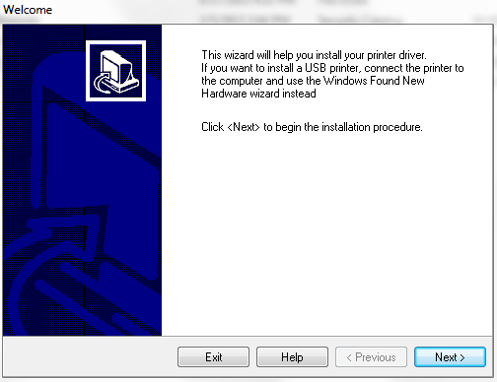

Select TTM430
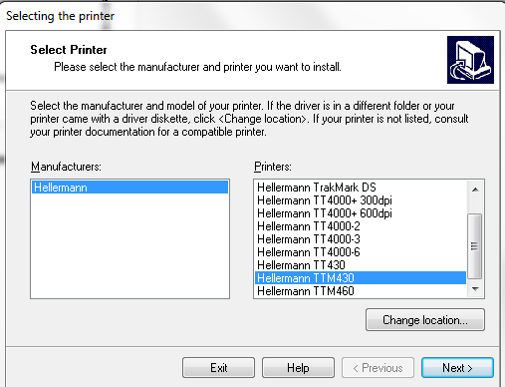

Next

Choose a USB Port that is NOT used by any other device. This must only be for the printer.
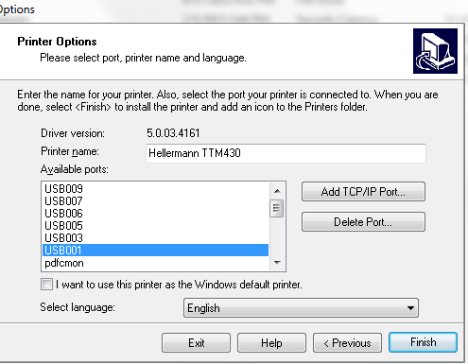

FINISH

Congratulations, you have successfully set up your TTM430!

